# NO:4

**AIM**: program to test the logical operators.

**Procedure:**

#!/bin/bash

read -p "Enter first number " a

read -p "Enter second number " b

if(($a == "true" & $b == "true"))

then

echo "Both are true"

else

echo "Both are not true"

fi

if(($a == "true" || $b == "true"))

then

echo "either one is true"

else

echo "either one is not true"

fi

if((! $a == "true"))

then

echo "a was initially false"

else

echo "a was initially true"

fi

**output:**

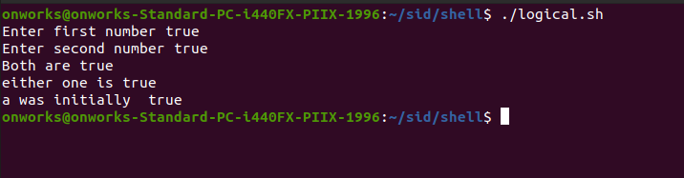

# Result

The program was executed and the result was successfully obtained. Thus CO3 was obtained